|  |  |
| --- | --- |
| *Pacific Gas and Electric Company* | |
| Release 9.5.1b Install Guide | |
|  |  |
|  |  |
| Project | ED AM/GIS |
|  |  |
| Prepared by | Subhankar Baidya |
| Date | 5/25/2015 |
| Version | 1.0 |
| Version Type | Draft |

|  |  |  |  |
| --- | --- | --- | --- |
| Revision History | | | |
| Document # | Date | Author | Summary of Changes |
| 1.0 | 05/20/2015 | Subhankar Baidya | Initial Document Creation |

# Introduction

## Purpose

This document is intended to detail the implementation and configuration steps required to implement modified schematics 500 scale Anno expressions. This document describes the various configuration aspects required to complete any manual or automatic patch associated with this release. Each section in this document contains the steps required to patch the system in production.

## Terms Used

|  |  |
| --- | --- |
| OOTB | Out of the box. Unmodified from the commercial version. |
| TFS | Team Foundation Server |

## External Documents

Referenced are any external configuration documents or exports. These are documents that contain more detailed information about configuring a system or documents that can be loaded into an application to perform the configuration detailed in this document.

## List of Fixes

Below is the list of change requests detailing all fixes for the data model for this release:

|  |  |
| --- | --- |
| **Item Number** | **Title** |
| 21881 | Modify Schematics 500 scale Anno expressions |
| 17291 | New SubstationSchemAnno Feature Linked Anno Class |
| 21919 | Version SchemStreetAnno500 |

## Summary of Steps to Complete Patch

These are the high-level steps to complete the installation and configuration of the data model patch. Use this table as a guide for completing the installation. Links are provided that can lead either within the document for detailed explanations or to external sites such as Sharepoint.

Contents

1 Introduction 3

1.1 Purpose 3

1.2 Terms Used 3

1.3 External Documents 3

1.4 List of Fixes 3

1.5 Summary of Steps to Complete Patch 3

2 Open a Database Connection in ArcCatalog 5

3 21881 - Modify Schematics 500 scale Anno expressions 6

4 17291: New SubstationSchemAnno Feature Linked Anno Class 18

5 21919: Version SchemStreetAnno500 31

6 Data Model Version Table 32

7 Known Issues 33

# Open a Database Connection in ArcCatalog

1. Open ArcCatalog.
2. Within the Catalog Tree, expand “Database Connections” and open the active connection for this process. This is the connection that is referenced in the change request associated with this document (EDGIS<DB name in the format X#Y> )

# 21881 - Modify Schematics 500 scale Anno expressions

1. Get the exclusive access of EDGIS
2. Expand Electric Dataset and follow below instructions:
3. **Navigate to EDGIS.CapacitorBankSchem500Anno**
   1. Right click on the feature class, select “Properties…”

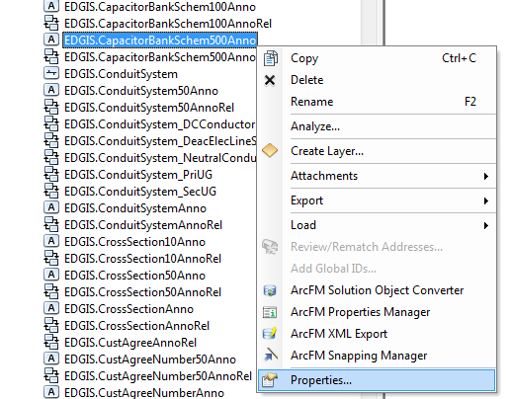

* 1. Go to “Annotation Classes” tab. Select “**Default**” annotation class.

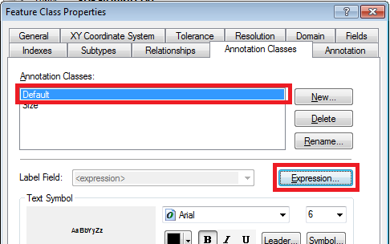

* 1. Click “**Expression…**” button.
  2. Check the “**Advanced**” checkbox if not already checked.

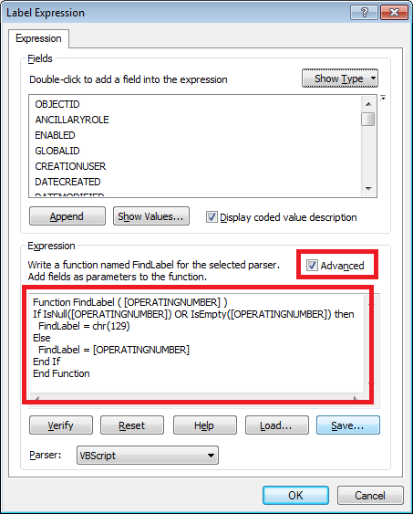

* 1. Delete existing codes from the text area. Copy the code given below and paste it in the same text area:

Function FindLabel ( [OPERATINGNUMBER] )

retVar = [OPERATINGNUMBER]

If IsNull(retVar) OR IsEmpty(retVar) then

FindLabel = chr(32)

Else

FindLabel = retVar

End If

End Function

* 1. Click “**Verify**” button to make sure the code is valid. Click “OK”. Click “Apply”.
  2. Select “**Size**” annotation class.

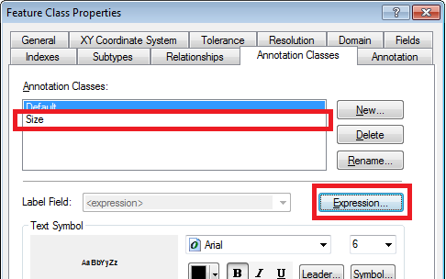

* 1. Click “**Expression…**” button.
  2. Check the “**Advanced**” checkbox if not already checked.
  3. Delete existing codes from the text area. Copy the code given below and paste it in the same text area.

Function FindLabel ( [TotalKVAR], [SubtypeCD] )

if [SubtypeCD] = "1" then

myVar = "F"

else

myVar = "S"

end if

if ( [SubtypeCD] = "1" or [SubtypeCD] = "2" ) then

retVar = [TotalKVAR] & myVar

else

retVar = [TotalKVAR]

end if

If IsNull(retVar) OR IsEmpty(retVar) then

FindLabel = chr(32)

Else

FindLabel = retVar

End If

End Function

* 1. Click “**Verify**” button to make sure the code is valid. Click “OK”. Click “Apply”. Click “OK”.

1. **Navigate to EDGIS.DeviceGroupSchem500Anno**
   1. Right click on the feature class, select “Properties…”
   2. Go to “Annotation Classes” tab. Select “**Default**”. Click “**Expression**…” button.
   3. Check the “**Advanced**” checkbox if not already checked.
   4. Delete existing codes from the text area. Copy the code given below and paste it in the same text area:

Function FindLabel ( [DEVICEGROUPNAME] )

retVar = [DEVICEGROUPNAME]

If IsNull(retVar) OR IsEmpty(retVar) then

FindLabel = chr(32)

Else

FindLabel = retVar

End If

End Function

* 1. Click “**Verify**” button to make sure the code is valid. Click “OK”. Click “Apply”. Click “OK”.

1. **Navigate to EDGIS.DynProtDevSchem500Anno**
   1. Right click on the feature class, select “Properties…”
   2. Go to “Annotation Classes” tab. Select “**Default**”. Click “**Expression**…” button. Check the “**Advanced**” checkbox if not already checked.
   3. Delete existing codes from the text area. Copy the code given below and paste it in the same text area.

Function FindLabel ( [OperatingNumber], [MULTIFUNCTIONALIDC], [NORMALPOSITION_A], [NORMALPOSITION_B], [NORMALPOSITION_C] )

if [MULTIFUNCTIONALIDC] = "Yes" AND [NORMALPOSITION_A] = "Open" OR [NORMALPOSITION_B] = "Open" OR [NORMALPOSITION_C] = "Open" then

retVar = "<CLR green='150'> " & [OperatingNumber] & "-MF" & " </CLR>"

elseif [MULTIFUNCTIONALIDC] = "Yes" AND [NORMALPOSITION_A] = "Closed" AND [NORMALPOSITION_B] = "Closed" AND [NORMALPOSITION_C] = "Closed" then

retVar = [OperatingNumber] & "-MF"

elseif [MULTIFUNCTIONALIDC] = "No" AND [NORMALPOSITION_A] = "Open" OR [NORMALPOSITION_B] = "Open" OR [NORMALPOSITION_C] = "Open" then

retVar = "<CLR green='150'> " & [OperatingNumber] & " </CLR>"

elseif [MULTIFUNCTIONALIDC] = "No" AND [NORMALPOSITION_A] = "Closed" AND [NORMALPOSITION_B] = "Closed" AND [NORMALPOSITION_C] = "Closed" then

retVar = [OperatingNumber]

elseif isnull([MULTIFUNCTIONALIDC]) AND [NORMALPOSITION_A] = "Open" OR [NORMALPOSITION_B] = "Open" OR [NORMALPOSITION_C] = "Open" then

retVar = "<CLR green='150'> " & [OperatingNumber] & " </CLR>"

elseif isnull([MULTIFUNCTIONALIDC]) AND [NORMALPOSITION_A] = "Closed" AND [NORMALPOSITION_B] = "Closed" AND [NORMALPOSITION_C] = "Closed" then

retVar = [OperatingNumber]

End if

If IsNull(retVar) OR IsEmpty(retVar) then

FindLabel = chr(32)

Else

FindLabel = retVar

End If

End Function

* 1. Click “**Verify**” button to make sure the code is valid. Click “OK”. Click “Apply”.
  2. Select “**Size**” annotation class.
  3. Click “**Expression…**” button.
  4. Check the “**Advanced**” checkbox if not already checked.
  5. Delete existing codes from the text area. Copy the code given below and paste it in the same text area:

Function FindLabel ( [SubtypeCD], [CCRating], [SwitchModeIdc] )

If [SubtypeCD] = "Interrupter" and [SwitchModeIdc] = "Yes" then

retVar = [CCRating] + "-SM"

else

retVar = [CCRating]

End if

If IsNull(retVar) OR IsEmpty(retVar) then

FindLabel = chr(32)

Else

FindLabel = retVar

End If

End Function

* 1. Click “**Verify**” button to make sure the code is valid. Click “OK”. Click “Apply”. Click “OK”.

1. **Navigate to EDGIS.ElecStitchPointSchem500Anno**
   1. Right click on the feature class, select “Properties…”
   2. Go to “Annotation Classes” tab. Select “**Default**”. Click “**Expression**…” button.
   3. Check the “**Advanced**” checkbox if not already checked.
   4. Delete existing codes from the text area. Copy the code given below and paste it in the same text area:

Function FindLabel ( [CIRCUITID] )

retVar = Right([CIRCUITID],4)

If IsNull(retVar) OR IsEmpty(retVar) then

FindLabel = chr(32)

Else

FindLabel = retVar

End If

End Function

* 1. Click “**Verify**” button to make sure the code is valid. Click “OK”. Click “Apply”. Click “OK”.

1. **Navigate to EDGIS.FaultIndicatorSchem500Anno**
   1. Right click on the feature class, select “Properties…”
   2. Go to “Annotation Classes” tab. Select “**Default**”. Click “**Expression**…” button.
   3. Check the “**Advanced**” checkbox if not already checked.
   4. Delete existing codes from the text area. Copy the code given below and paste it in the same text area:

Function FindLabel ( [SUBTYPECD] , [FITYPE] )

If [SUBTYPECD] = "Fault Indicator" and [FITYPE] = "Manual Reset" then

retVar = "M"

end if

If IsNull(retVar) OR IsEmpty(retVar) then

FindLabel = chr(32)

Else

FindLabel = retVar

End If

End Function

* 1. Click “Verify” button to make sure the code is valid. Click “OK”. Click “Apply”. Click “OK”.

1. **Navigate to EDGIS.FuseSchem500Anno**
   1. Right click on the feature class, select “Properties…”
   2. Go to “Annotation Classes” tab. Select “**Default**”. Click “**Expression**…” button. Check the “**Advanced**” checkbox if not already checked.
   3. Delete existing codes from the text area. Copy the code given below and paste it in the same text area.

Function FindLabel ( [OPERATINGNUMBER], [NORMALPOSITION_A], [NORMALPOSITION_B], [NORMALPOSITION_C] )

if [NORMALPOSITION_A] = "Open" OR [NORMALPOSITION_B] = "Open" OR [NORMALPOSITION_C] = "Open" then

retVar = "<CLR green='125'> " & [OPERATINGNUMBER] & " </CLR>"

else

retVar = [OPERATINGNUMBER]

end if

If IsNull(retVar) OR IsEmpty(retVar) then

FindLabel = chr(32)

Else

FindLabel = retVar

End If

End Function

* 1. Click “**Verify**” button to make sure the code is valid. Click “OK”. Click “Apply”.
  2. Select “**Type**” annotation class.
  3. Click “**Expression…**” button.
  4. Check the “**Advanced**” checkbox if not already checked.
  5. Delete existing codes from the text area. Copy the code given below and paste it in the same text area:

Function FindLabel ( [LINKRATING], [LINKTYPE] )

vLinkRating = replace([LINKRATING]," A","")

vLinkTypeCode = [LINKTYPE]

if (vLinkTypeCode = "N") then

vLinkType = "N"

elseif (vLinkTypeCode = "T") then

vLinkType = "T"

elseif (vLinkTypeCode = "E") then

vLinkType = "E"

elseif (vLinkTypeCode = "K") then

vLinkType = "K"

elseif (vLinkTypeCode = "CL") then

vLinkType = "CL"

elseif (vLinkTypeCode = "FT") then

vLinkType = "FT"

elseif (vLinkTypeCode = "ELF") then

vLinkType = "ELF"

end if

retVar = vLinkRating & vLinkType

If IsNull(retVar) OR IsEmpty(retVar) then

FindLabel = chr(32)

Else

FindLabel = retVar

End If

End Function

* 1. Click “Verify” button to make sure the code is valid. Click “OK”. Click “Apply”. Click “OK”.

1. **Navigate to EDGIS.PriGenerationSchem500Anno**
   1. Right click on the feature class, select “Properties…”
   2. Go to “Annotation Classes” tab. Select “**Default**”. Click “**Expression**…” button.
   3. Check the “**Advanced**” checkbox if not already checked.
   4. Delete existing codes from the text area. Copy the code given below and paste it in the same text area:

Function FindLabel ( [SubtypeCD], [Capacity], [NameOfCoGenerator] )

If [SubtypeCD] = "CoGeneration" then

retVar = [Capacity] & vbCrLf & [NameOfCoGenerator]

End if

If IsNull(retVar) OR IsEmpty(retVar) then

FindLabel = chr(32)

Else

FindLabel = retVar

End If

End Function

* 1. Click “Verify” button to make sure the code is valid. Click “OK”. Click “Apply”. Click “OK”.

1. **Navigate to EDGIS.StepdownSchem500Anno**
   1. Right click on the feature class, select “Properties…”
   2. Go to “Annotation Classes” tab. Select “**Default**”. Click “**Expression**…” button. Check the “**Advanced**” checkbox if not already checked.
   3. Delete existing codes from the text area. Copy the code given below and paste it in the same text area.

Function FindLabel ( [OPERATINGNUMBER] )

retVar= [OPERATINGNUMBER]

If IsNull(retVar) OR IsEmpty(retVar) then

FindLabel = chr(32)

Else

FindLabel = retVar

End If

End Function

* 1. Click “**Verify**” button to make sure the code is valid. Click “OK”. Click “Apply”.
  2. Select “**Size**” annotation class.
  3. Click “**Expression…**” button.
  4. Check the “**Advanced**” checkbox if not already checked.
  5. Delete existing codes from the text area. Copy the code given below and paste it in the same text area:

Function FindLabel ( [OPERATINGVOLTAGE], [OUTPUTVOLTAGE], [RATEDKVA] )

retVar = Replace( [OPERATINGVOLTAGE], "kV", "") & "/" & Replace( [OUTPUTVOLTAGE], "kV", "") & " " & [RATEDKVA]

If IsNull(retVar) OR IsEmpty(retVar) then

FindLabel = chr(32)

Else

FindLabel = retVar

End If

End Function

* 1. Click “Verify” button to make sure the code is valid. Click “OK”. Click “Apply”. Click “OK”.

1. **Navigate to EDGIS.SwitchSchem500Anno**
   1. Right click on the feature class, select “Properties…”
   2. Go to “Annotation Classes” tab. Select “**Default**”. Click “**Expression**…” button. Check the “**Advanced**” checkbox if not already checked.
   3. Delete existing codes from the text area. Copy the code given below and paste it in the same text area.

Function FindLabel ( [OPERATINGNUMBER], [NORMALPOSITION_A], [NORMALPOSITION_B], [NORMALPOSITION_C] )

if [NORMALPOSITION_A] = "Open" OR [NORMALPOSITION_B] = "Open" OR [NORMALPOSITION_C] = "Open" then

retVar = "<CLR green='125'> " & [OPERATINGNUMBER] & " </CLR>"

else

retVar = [OPERATINGNUMBER]

end if

If IsNull(retVar) OR IsEmpty(retVar) then

FindLabel = chr(32)

Else

FindLabel = retVar

End If

End Function

* 1. Click “**Verify**” button to make sure the code is valid. Click “OK”. Click “Apply”.
  2. Select “**Size**” annotation class.
  3. Click “**Expression…**” button.
  4. Check the “**Advanced**” checkbox if not already checked.
  5. Delete existing codes from the text area. Copy the code given below and paste it in the same text area:

Function FindLabel ( [CCRating] )

if [CCRating] = "600A" then

retVar = "600A"

elseif [CCRating] = "800A" then

retVar = "800A"

end if

If IsNull(retVar) OR IsEmpty(retVar) then

FindLabel = chr(32)

Else

FindLabel = retVar

End If

End Function

* 1. Click “Verify” button to make sure the code is valid. Click “OK”. Click “Apply”. Click “OK”.

1. **Navigate to EDGIS.TransformerSchem500Anno**
   1. Right click on the feature class, select “Properties…”
   2. Go to “Annotation Classes” tab. Select “**Default**”. Click “**Expression**…” button. Check the “**Advanced**” checkbox if not already checked.
   3. Delete existing codes from the text area. Copy the code given below and paste it in the same text area.

Function FindLabel ( [OperatingNumber], [LIVEFRONTIDC] )

If [LIVEFRONTIDC] = "Yes" then

retVar = [OperatingNumber] & "-LF"

Else

retVar = [OperatingNumber]

End If

If IsNull(retVar) OR IsEmpty(retVar) then

FindLabel = chr(32)

Else

FindLabel = retVar

End If

End Function

* 1. Click “**Verify**” button to make sure the code is valid. Click “OK”. Click “Apply”.
  2. Select “**Size**” annotation class.
  3. Click “**Expression…**” button.
  4. Check the “**Advanced**” checkbox if not already checked.
  5. Delete existing codes from the text area. Copy the code given below and paste it in the same text area:

Function FindLabel ( [LABELTEXT2] )

retVar = [LABELTEXT2]

If IsNull(retVar) OR IsEmpty(retVar) then

FindLabel = chr(32)

Else

FindLabel = retVar

End If

End Function

* 1. Click “Verify” button to make sure the code is valid. Click “OK”. Click “Apply”. Click “OK”.

1. **Navigate to EDGIS.VoltageRegulatorSchem500Anno**
   1. Right click on the feature class, select “Properties…”
   2. Go to “Annotation Classes” tab. Select “**Default**”. Click “**Expression**…” button. Check the “**Advanced**” checkbox if not already checked.
   3. Delete existing codes from the text area. Copy the code given below and paste it in the same text area.

Function FindLabel ( [OPERATINGNUMBER] )

retVar = [OPERATINGNUMBER]

If IsNull(retVar) OR IsEmpty(retVar) then

FindLabel = chr(32)

Else

FindLabel = retVar

End If

End Function

* 1. Click “**Verify**” button to make sure the code is valid. Click “OK”. Click “Apply”.
  2. Select “**Size**” annotation class.
  3. Click “**Expression…**” button.
  4. Check the “**Advanced**” checkbox if not already checked.
  5. Delete existing codes from the text area. Copy the code given below and paste it in the same text area:

Function FindLabel ([UnitCount], [RatedAmps] )

If [UnitCount] > 1 then

retVar = [UnitCount] & "-" & [RatedAmps]

else

retVar = [RatedAmps]

End if

If IsNull(retVar) OR IsEmpty(retVar) then

FindLabel = chr(32)

Else

FindLabel = retVar

End If

End Function

* 1. Click “Verify” button to make sure the code is valid. Click “OK”. Click “Apply”. Click “OK”.

# 17291: New SubstationSchemAnno Feature Linked Anno Class

Description

One SubstationSchemAnno feature class is required to annotate substation name in Schematics.

 Annotation Feature Class: SubstationSchemAnno

Alias Name: SubstationSchemAnno

 Link to EDGIS.Substation as Feature linked Anno.

AutoCreate

Subtype Anno Class: Default

Reference Scale: 1 inch = 500 feet

Font: Arial (8), Black, Bold

Vertical Alignment: Center

Horizontal Alignment: Center

Text Background: Checked with below attributes:

Type: Line Callout

Gap: 0

Leader: Unchecked. Accent Bar: Unchecked, Boarder: Checked

Leader Tolerance: 0

Color: Solar Yellow, No Outline

Left, Right, Bottom, Top Margins: 0

 Label Expression:

 [NAME]

**Steps:**

1. Get the exclusive connection of EDGIS
2. Go to ElectricDataset 🡪 EDGIS.SubstationSchemAnno. Right click on it. **Delete**. Click “Yes” button on the popup window.
3. Right click on ElectricDataset. Select New 🡪 Feature Class…

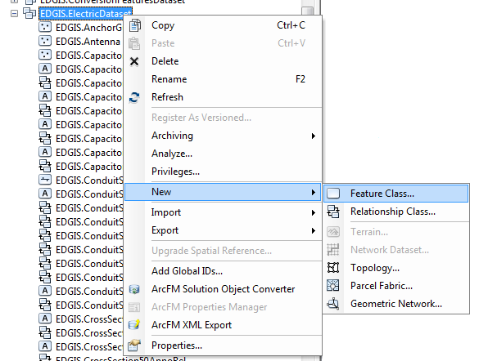

1. Fill the window forms as given below:

Name: SubstationSchemAnno

Alias Name: SubstationSchemAnno

Link to EDGIS.Substation as Feature linked Anno.

Auto Create

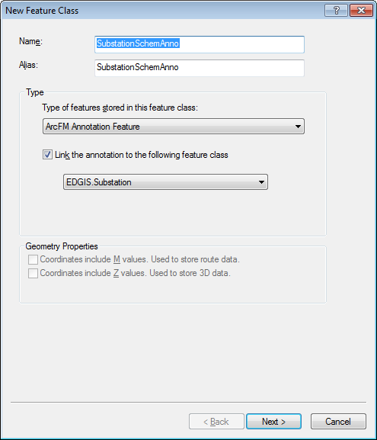

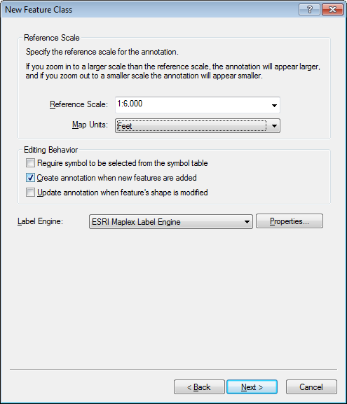

1. Fill the window forms as given below:

Subtype Anno Class: Default

Font: Arial (8), Black, **Bold** **[Click on Symbol… button]**

Vertical Alignment: Center

Horizontal Alignment: Center

Text Background: Checked with below attributes: **[Click on Leader… button]**

Type: Line Callout

Gap: 0

Leader: Unchecked. Accent Bar: Unchecked, Border: Checked

Leader Tolerance: 0

Color: Solar Yellow, No Outline

Left, Right, Bottom, Top Margins: 0

Label Expression:

 [NAME]

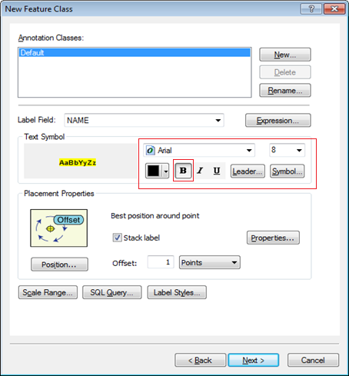

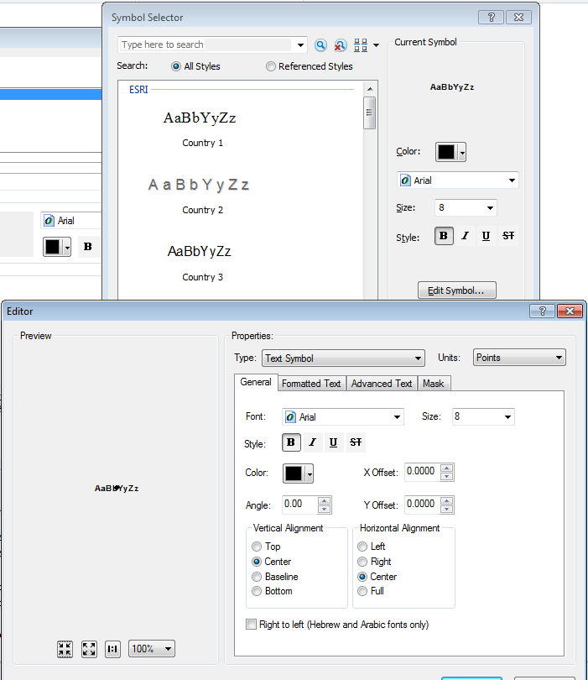

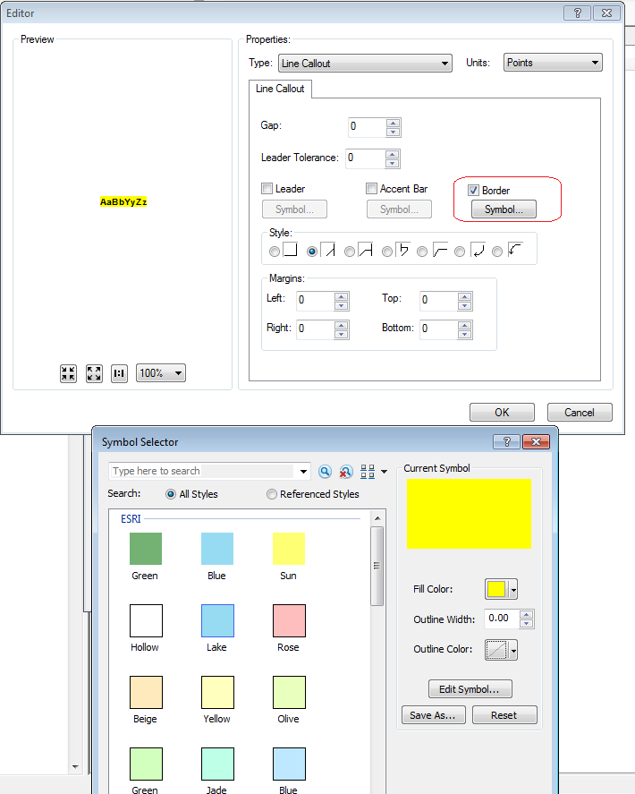

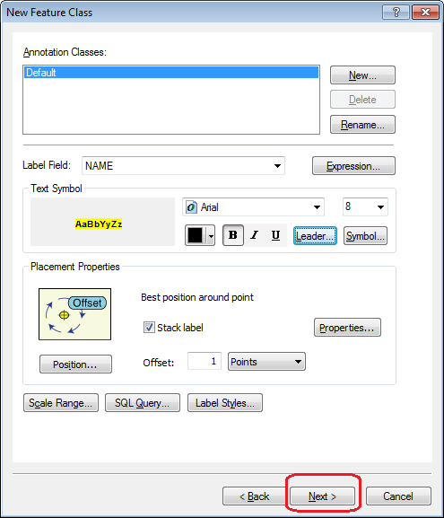

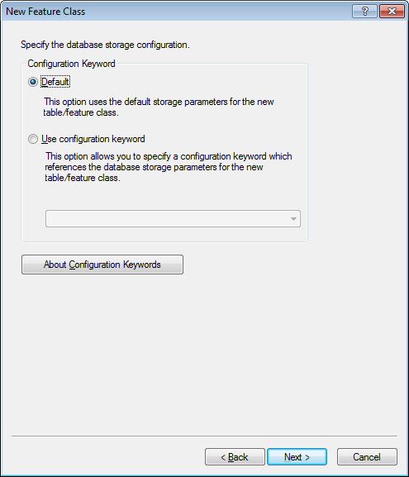

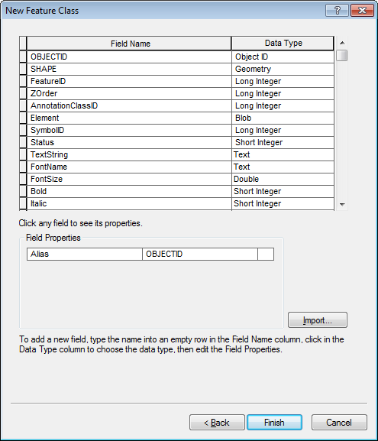

1. Right click on newly created “relationship” class. Rename it as **EDGIS.SubstationSchemAnnoRel**
2. Right click on EDGIS.SubstationSchemAnno. Select “ArcFM Properties Manager…”
3. Go to “Model Names” tab. Add PGE_SCHM500ANNO model name.

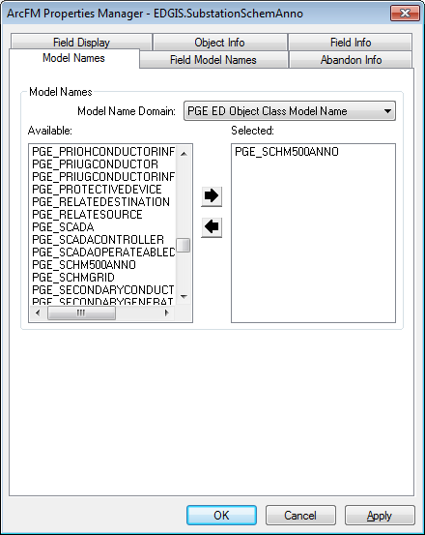

1. Click Apply button.
2. Go to Field Model Names tab. Add PGE_FONTSIZE field model name to FONTSIZE field.

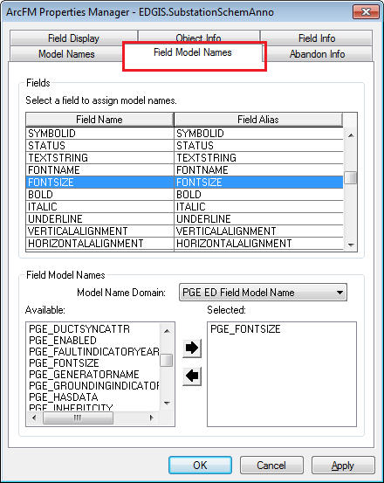

1. Go to “Object Info” tab. Add “PGE Annotation Half Font Size AU” at On Feature Create.

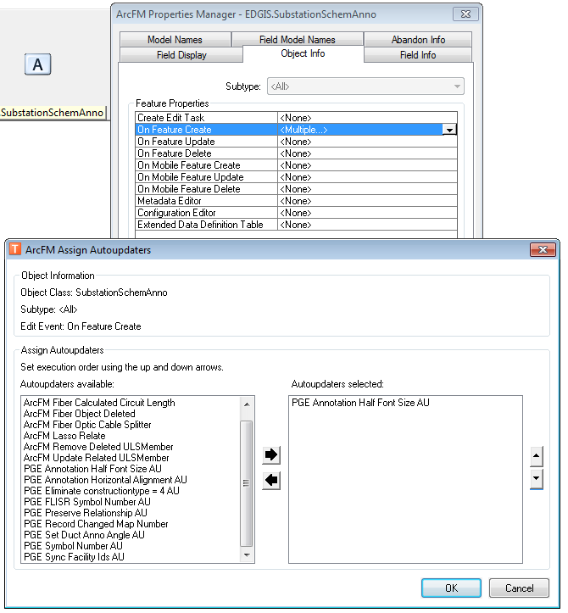

1. Click OK. Click OK.
2. Right-click on the ElectricDataset and select Privileges
3. Enter **SDE_EDITOR** for the role and select GRANT for “View” and “Edit” permissions
4. Click OK
5. Repeat steps 14 and 15 for **DAT_EDITOR**
6. Right-click on the ElectricDataset and select Privileges again
7. Enter **SDE_VIEWER** for the role and select GRANT for “View” permissions. Leave Edit blank.
8. Click OK.
9. Repeat steps 15,16 and 17 for the following roles:
   1. **DATACONV**
   2. **GISINTERFACE**
   3. **GIS_INTERFACE**

# 21919: Version SchemStreetAnno500

1. Open ArcCatlog 10.0
2. Log into EDER as edgis.
3. Right click on EDGIS.SchemStreetAnno500 and select "Register as Versioned..." (Feature class outside of Datasets.)

**Note: Do not check the**

**"Register the selected objects with the option to move edits to base."**

1. Set privileges:

SDE_EDITOR (view and edit), SDE_VIEWER (view), DATACONV (view), DAT_EDITOR (view), GISINTERFACE (view, edit), GIS_INTERFACE (view, edit)

# Data Model Version Table

**Database Configuration:**

1. Open SQL Plus.
2. Log in using the same server and user as was used in section 2.  
     
   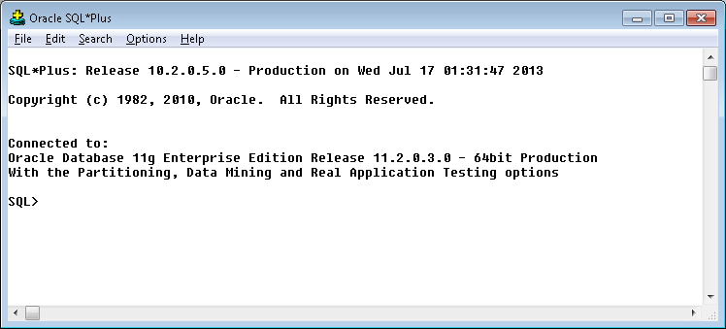
3. Run the SQL below:

update pgedatamodelversion set currentidc='N' where currentidc='Y';

insert into pgedatamodelversion (OBJECTID, CURRENTIDC, DATEAPPLIED, APPLIEDBYPERSONNAME, MODELVERSION) values (**INSERT NEXT VALID ID**,'Y',sysdate,'**<INSERT TEAM MEMBER DONE BY>**','**9.5.1.b** **TFS Ticket <INSERT TFS#>**');

commit;

# Known Issues

<Please List any other issues encountered here while following the document>